SOUTH HEIGHTON BONFIRE SOCIETY

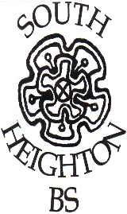

BONFIRE JUMPER ORDER FORM

When you join South Heighton Bonfire Society you may wish to either purchase or knit a blue and yellow stripey jumper (known as “smugglers jumper” or “guernsey”) to wear when joining the procession. This is entirely optional as you may prefer to wear costume. Please note that wearing of striped t-shirts/rugby shirts in place of a jumper is not accepted.
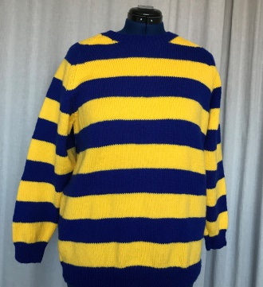

If you wish to knit your own a pattern and details of the correct yarn colours can be found at http://southheighton.org/bonfire/jumpers/

To order a hand knitted jumper(s) please fill out the form below.

Please note that each jumper may take several weeks to produce.

We hold sample sizes in stock and recommend you come and try them on before you place your order as once ordered they cannot be returned. Please contact Jane Harris on jhharris@hotmail.co.uk /07764 614166

NAME: Click here to enter your name .

CONTACT NUMBER: Click here to enter your phone number.

Small  *38”/25”/25” | £27 each | No. Required : Enter no. | Cost £ Enter total £
Medium  *42”/27”/27” | £40 each | No. Required : Enter no. | Cost £ Enter total £
Large  *48”/31”/31” | £45 each | No. Required : Enter no. | Cost £ Enter total £
*chest/sleeve (neck to cuff)/back length (actual made up size in INCHES) |  |  | Total £  Enter grand total £

Please return this form to jhharris@hotmail.co.uk and make payment online to:

Lloyds Account Name: South Heighton Village Hall Management Committee
Sort Code: 30-95-01
Account number: 00854262
Please make payment reference “Jumper <your surname>”

